Answer 9
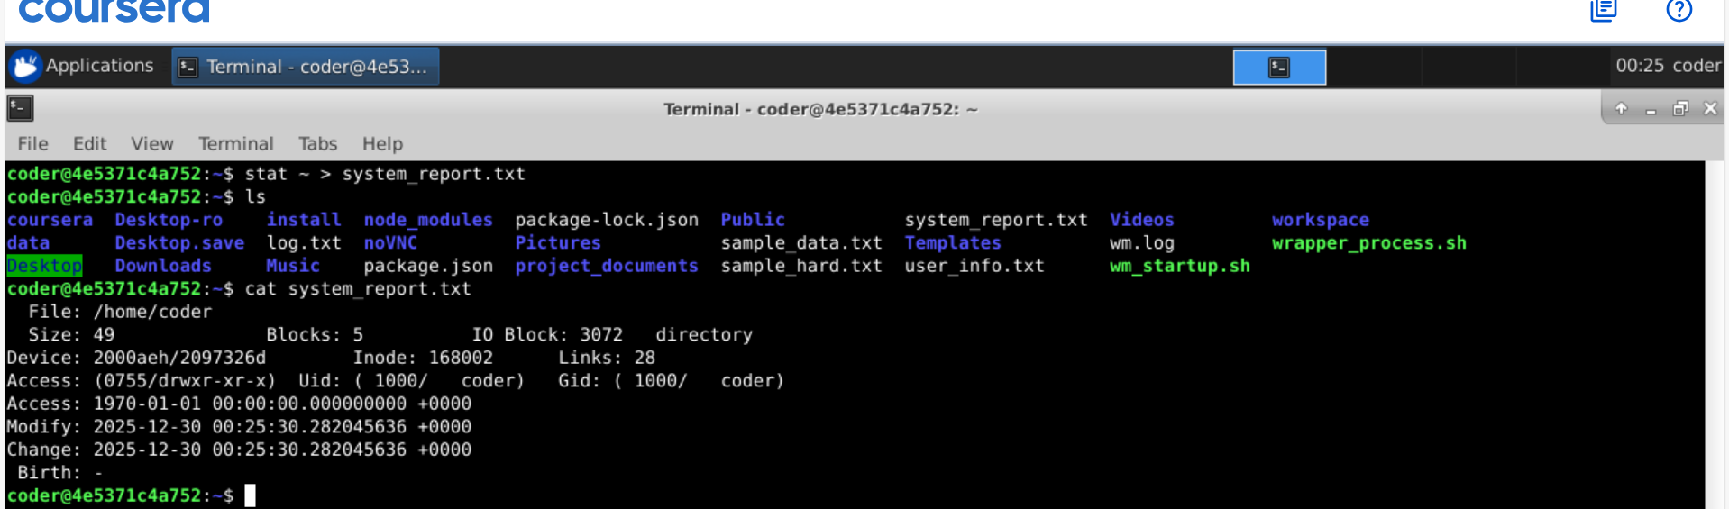
Explanation: using > we can send standard output to a file. In above, I used stat command on home directory and send the output to system_report.txt. >> this will append the file.

